Wood, David (from Linked In)

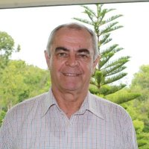

St Marys High 1960 – 1964. BSc Forestry ANU 1969. Project Manager, Vanuatu Sustainable Forest Utilisation Project Hassall & Associates 1995 –2000. Community Support Co-ordinator/ Implementation Officer Burdekin Dry Tropics Board 2001 –2004 Townsville. Vegetation Strategist Ergon Energy 2004 –2011. Manager Vegetation and Sustainable Pole Forests Ergon Energy 2011 –2013 Townsville. Forestry or Utility Vegetation Consulting 2013 –, Townsville.

